**Ideation Phase**

**Define the Problem Statements**

|  |  |
| --- | --- |
| Date | 29/JUNE/2025 |
| Team ID | LTVIP2025TMID32012 |
| Project Name | Citizen ai |
| Maximum Marks | 2 Marks |

**Customer Problem Statement Template:**

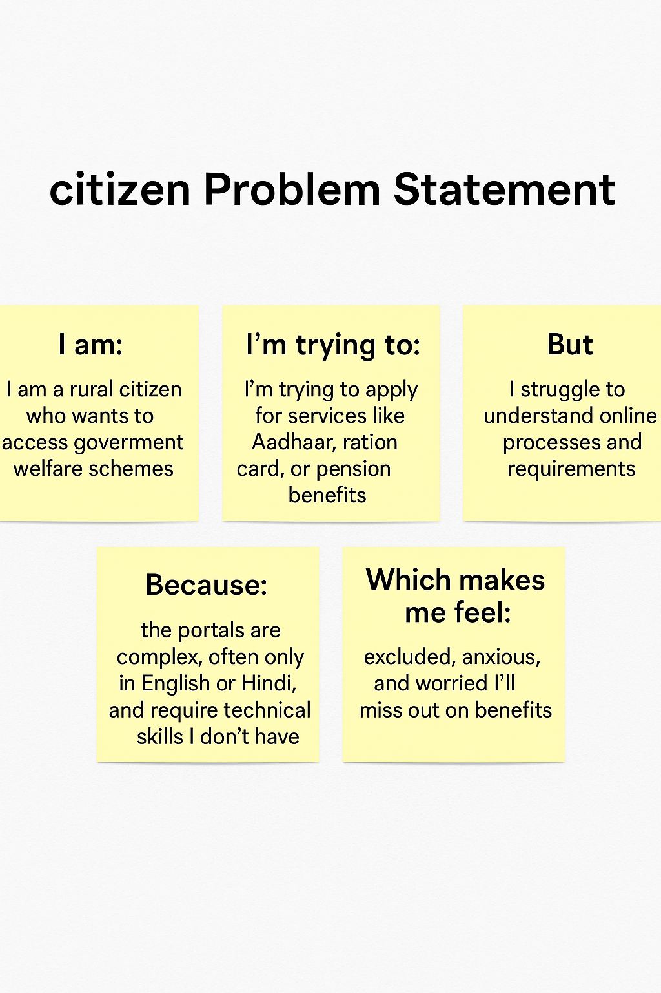

|  |  |  |  |  |  |
| --- | --- | --- | --- | --- | --- |
| **Problem Statement (PS)** | **I am (Customer)** | **I’m trying to** | **But** | **Because** | **Which makes me feel** |
| PS-1 | a rural citizen who needs access to government welfare schemes. | apply for government services like Aadhaar, ration card, or pension schemes. | I find it difficult to understand the application process and available schemes online. | most portals are only in English or Hindi, require digital literacy, and have complex navigation. | excluded, frustrated, and unsure about whether I’m eligible or doing things right. |
| PS-2 | a college student who wants to track my scholarship and ID-related application status. | check the progress of my applications and receive updates or reminders. | there’s no central system to manage or notify me in real-time. | government portals are fragmented, and I have to visit multiple websites or offices manually. | overwhelmed, disorganized, and worried that I might miss deadlines or updates. |